M. Hemalatha
192472042
CSA6502
GEN-AI

Q2. Few-Shot Classification
Write a few-shot prompt (using 3 examples) that classifies customer reviews as Positive, Negative, or Neutral. Show your 3 examples and the final prompt.
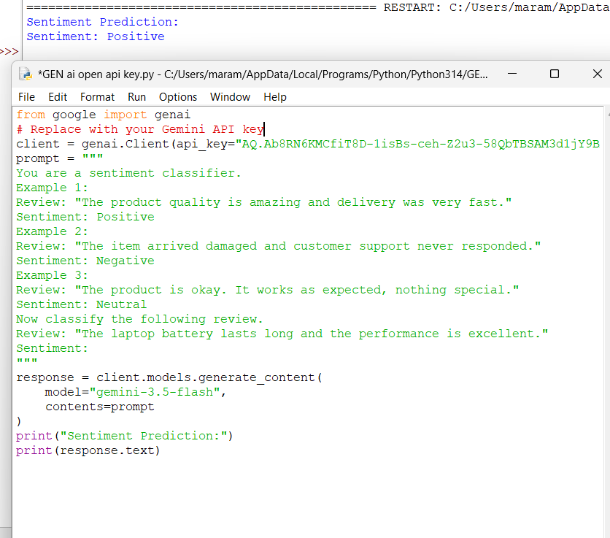

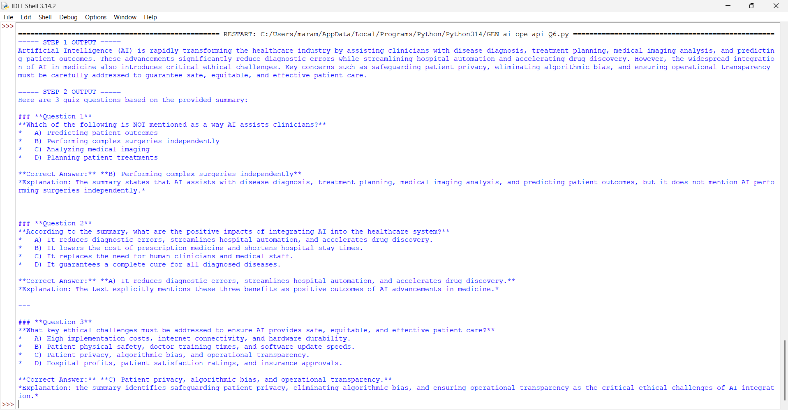
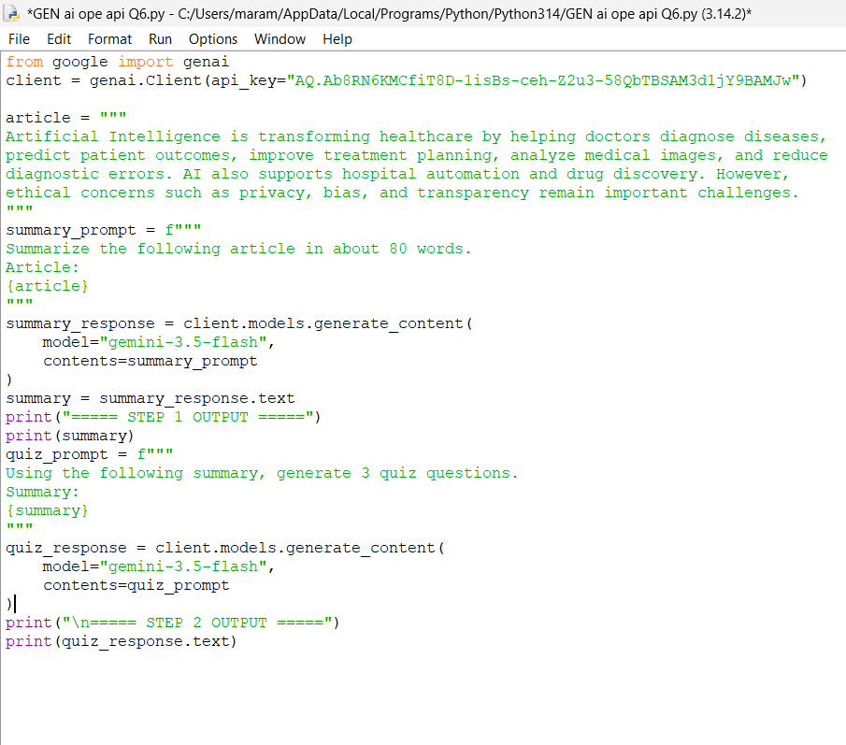
Q6. Prompt Chaining
Design a 2-step prompt chain: Step 1 summarizes a long article; Step 2 takes that summary and generates 3 quiz questions from it. Write both prompts and show how Step 1's output feeds Step 2.

